Name: Kiran K V

Batch: 2024-11761

Elastic Load Balancer Task: - (Application Load Balancer)

Create highly available architecture such that homepage should available homepage of e-commerce and iPhone website should be available on routing path **/mobile/,** PlayStation should be available on routing **/electronics/.**

Step 1: Created Red Hat Linux EC2-instance server for hosting e-commerce and mobile, electronics applications with the name **Assignment-LoadBalancer**.

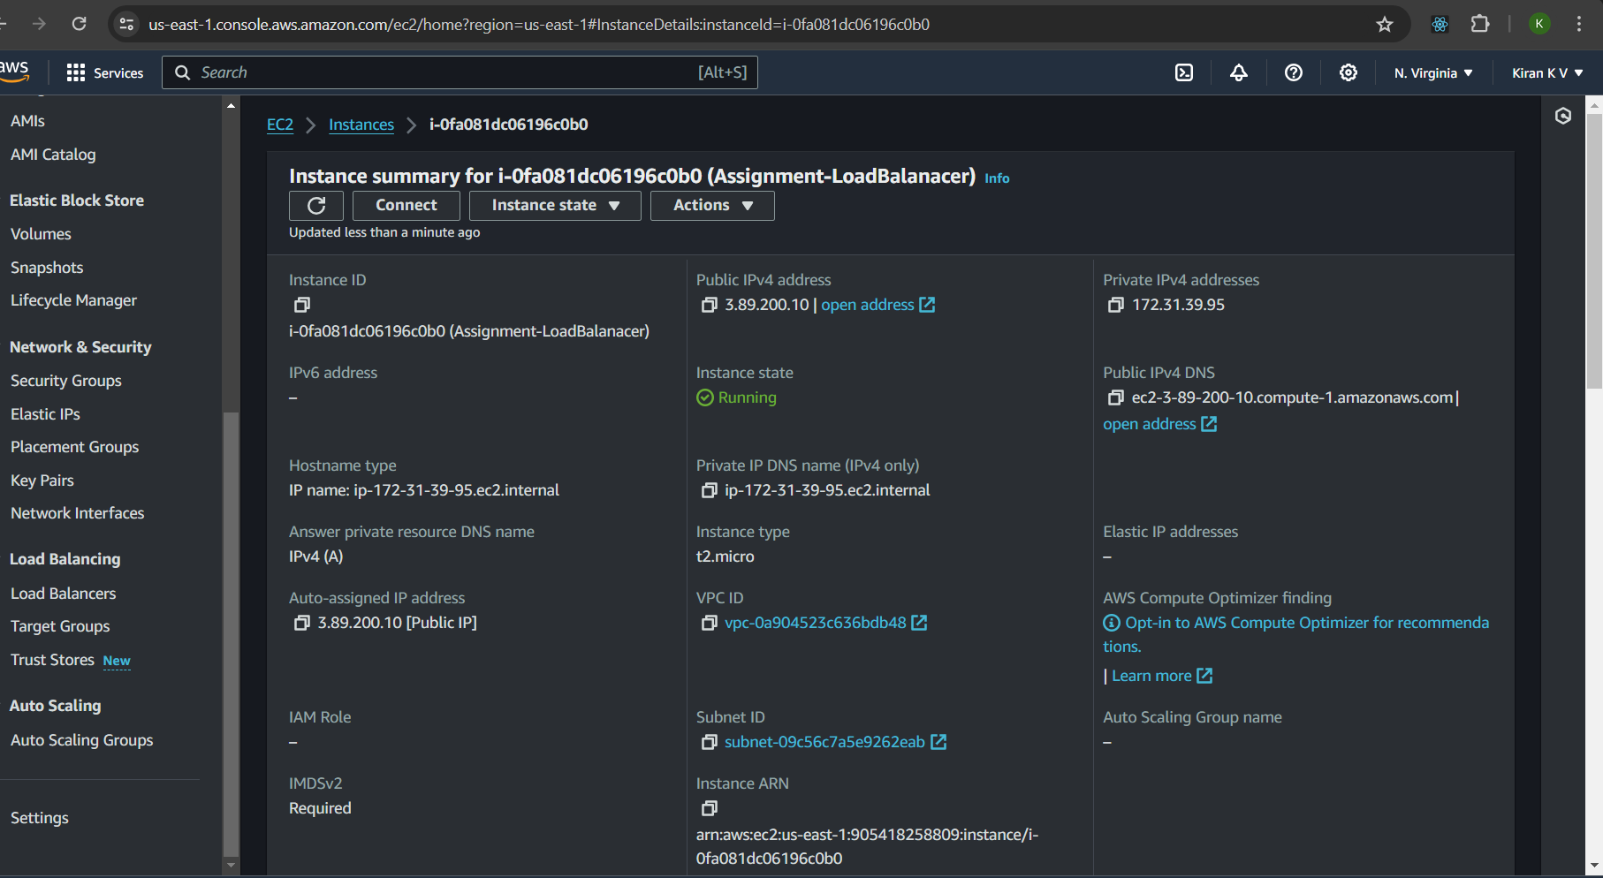

Step 2: Hosted e-commerce application that is **(amazon application) in** main directory (/var/www/html/index.html) and created mobile and electronics directories, for mobile application index file **(iPhone application)** added in mobile directory (/var/www/html/mobile/index.html) and for electronics application index file **(PlayStation application**) added in electronics directories(/var/www/html/electronics/index.html).

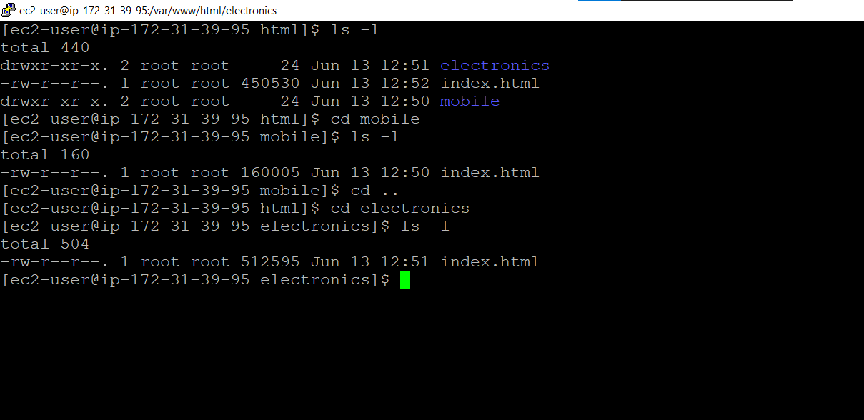

Step 3: Started httpd server and enabled.

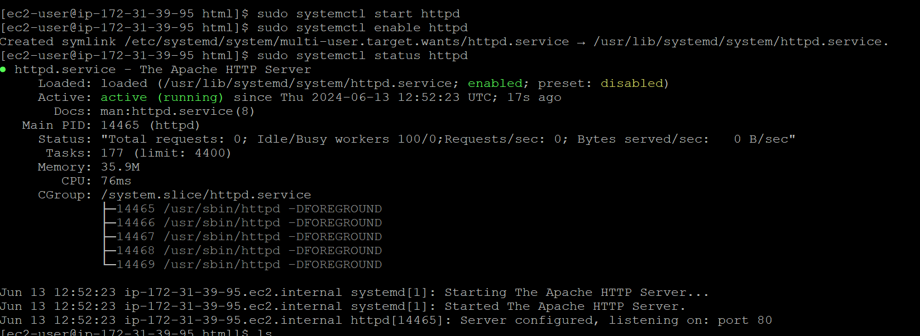

Step 4: Created Target groups for e-commerce application and mobile, electronics application aligning with specific health-check paths and ec2-instance servers.

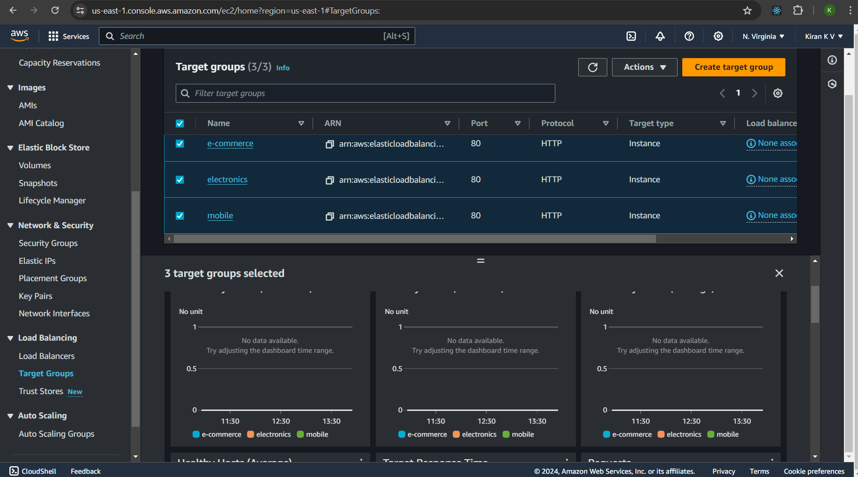

Step 5 : Created security group for load balancer with allowing http port 80.

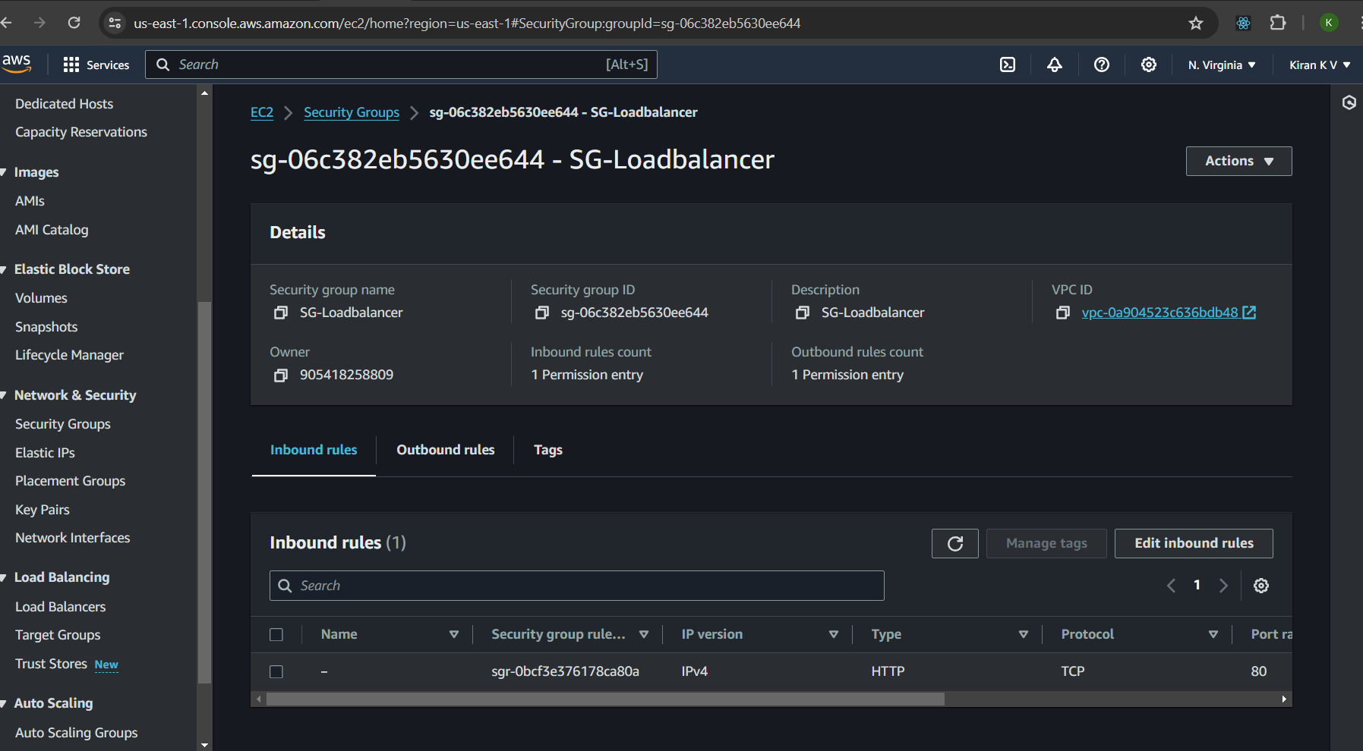

Step 6: Created Application Load Balancer with security group http and listener port 80, attached ec2-instance server

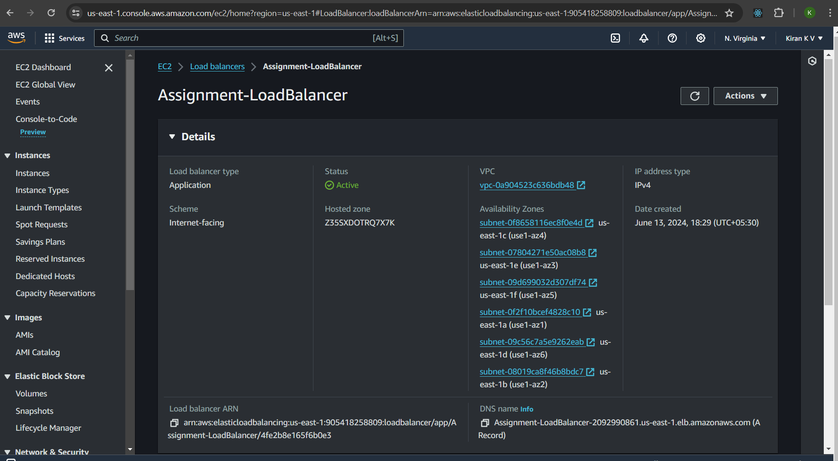

Step 7: Added listener port rules with specific conditions and priority wise.

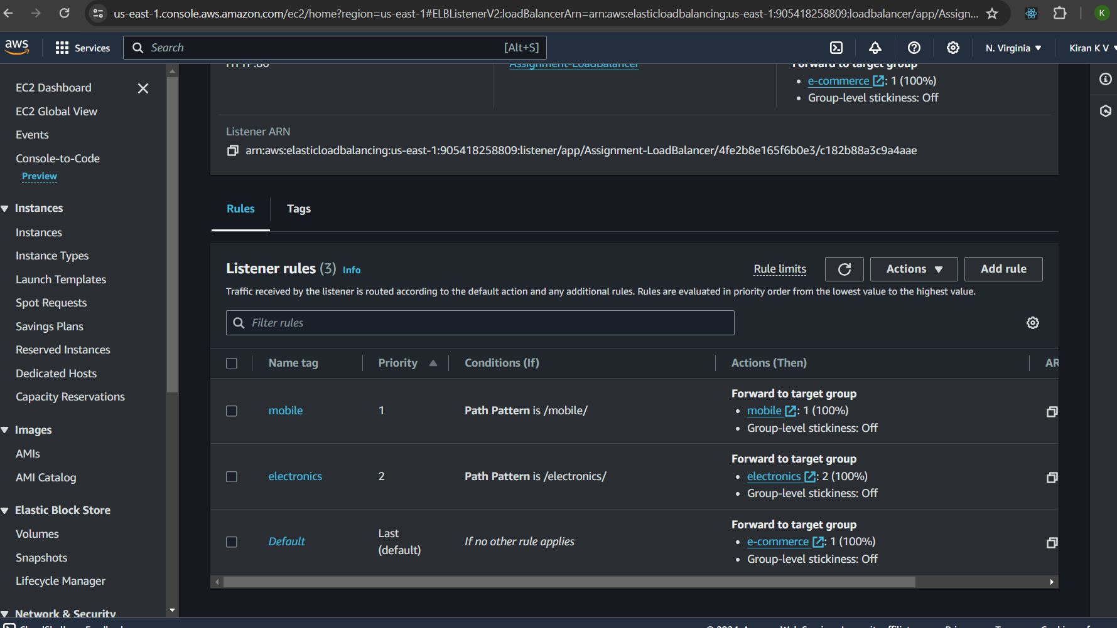

Step 8: Created Application Load Balancer and tested in internet.

Testing:

DNS url : Assignment-LoadBalancer-2092990861.us-east-1.elb.amazonaws.com

HomePage: <http://assignment-loadbalancer-2092990861.us-east-1.elb.amazonaws.com/>

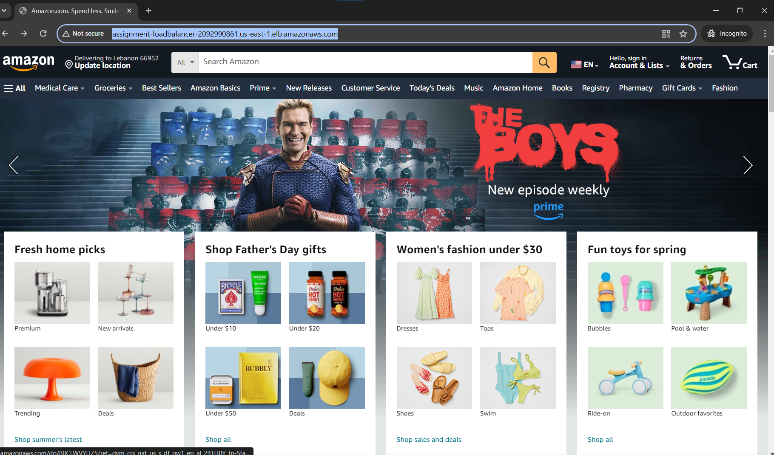

Mobilepage: <http://assignment-loadbalancer-2092990861.us-east-1.elb.amazonaws.com/mobile/>

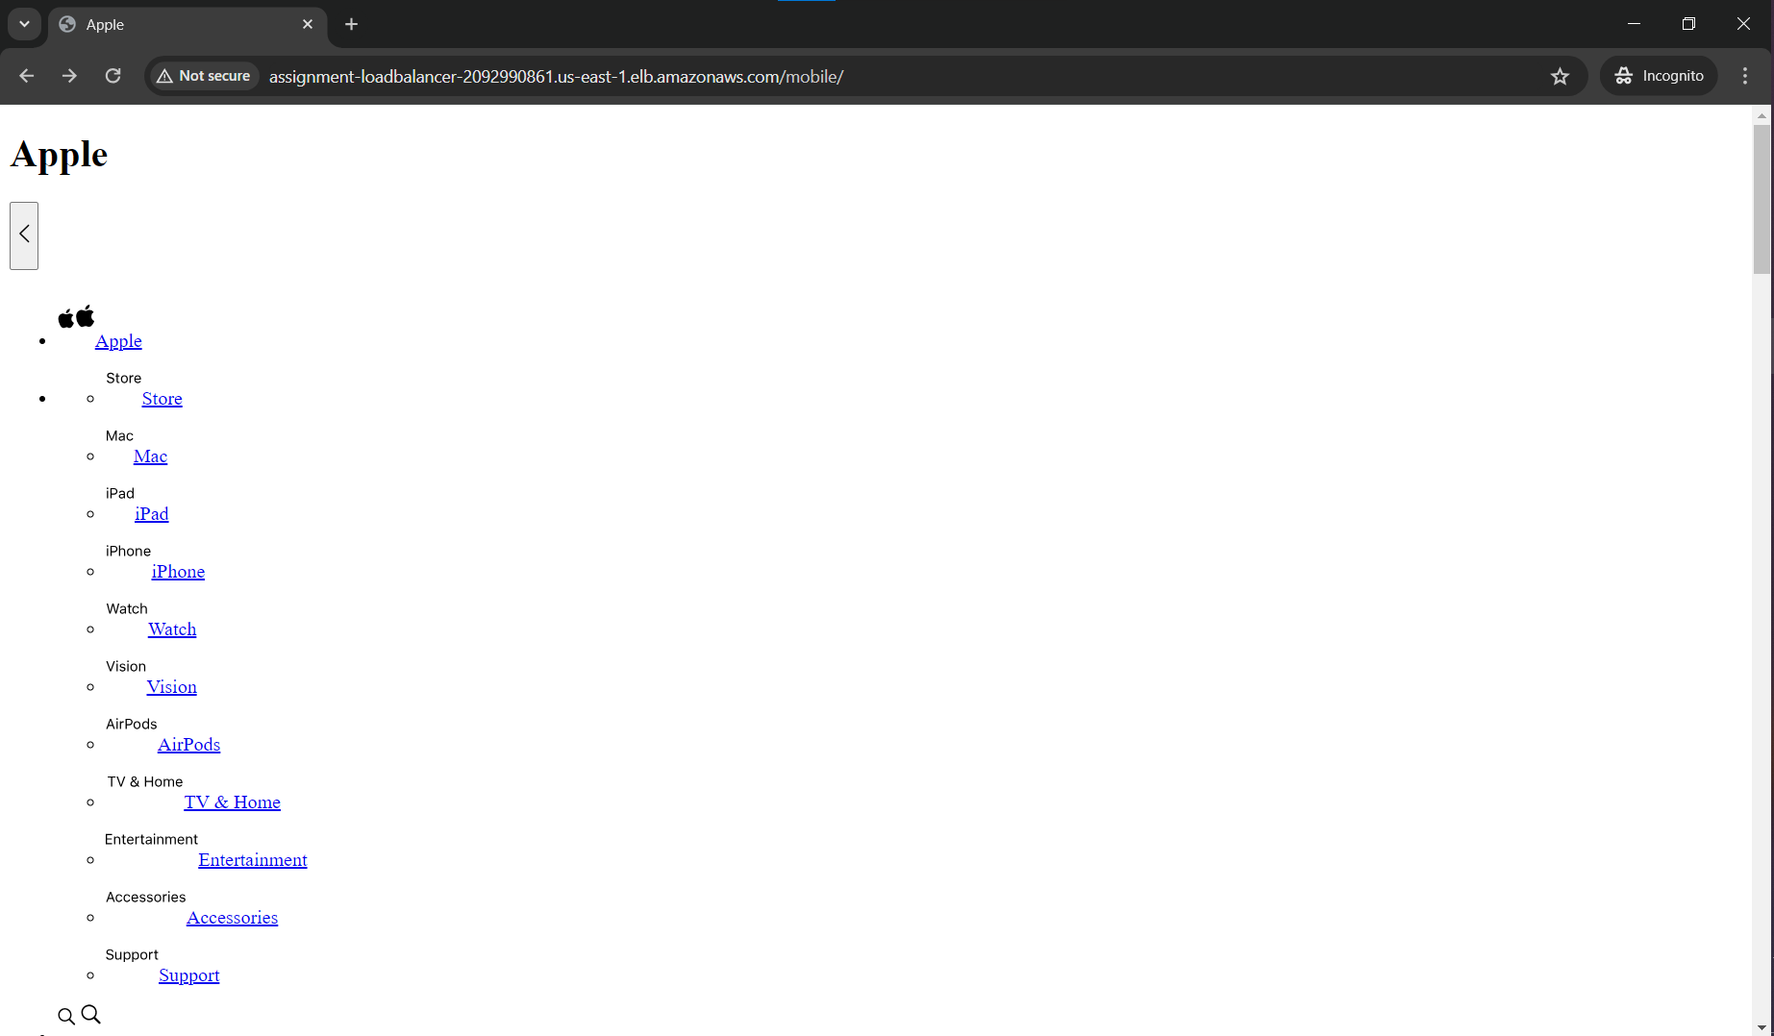

ElectronicsPage: <http://assignment-loadbalancer-2092990861.us-east-1.elb.amazonaws.com/electronics/>

